(Approx. 228 words)

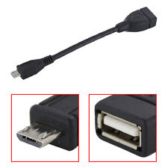
OTG Cable/Adapter (On-the-Go)
By Frank Ramsey, Editor, Akron Canton PCUG, Ohio
www.acpcug.org
aframsey (at) yahoo.com

How do you accomplish the transfer of files between a mobile device and your PC?
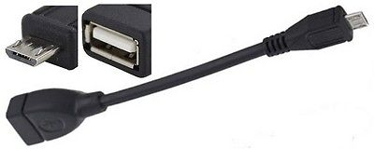
There are a number of methods, including connecting the device to a PC/MAC via a USB cable, use an application to connect over Wi-Fi and others.

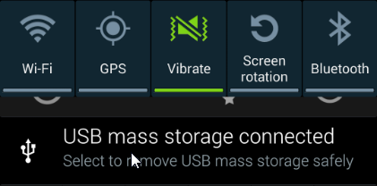
An additional method would be to transfer files to a USB Flash drive. Since few Android devices have a full- size USB Type A port, how do you connect a flash?

Enter the OTG Cable. A typical OTB cable is shown above. One end is the USB Type A female, the other end typically USB micro male. These are available from a number of sources including eBay for prices ranging from under a $1 to $5 or more.
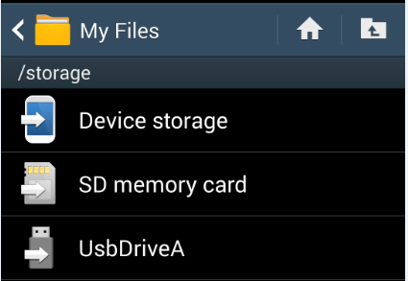
You plug the flash drive into the Type A female connection and plug the USB micro male into the Android device.
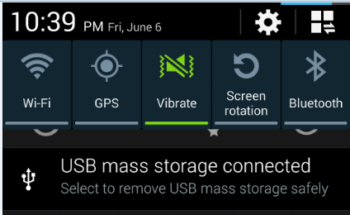
Typically the Android device will recognize the flash drive and eventually it will show up in File Manager. I say eventually because the flash drive must be scanned by the Android device. Depending on the size of the flash drive and the speed of the Android device, it may take a little time for the USB drive to show up. Be patient.
Now you can copy files to/from the flash drive.

